Chapter 2: Review of the Literature on The Topic

2.1. History of Banking and Transactions

Banking is related to ancient history. First Banks were recorded early 2000 BCE in Babilon. It was services of buying and selling together with saving the financial deposits. Most of such “protobanks” were dealing with physical coins and providing services of currency exchange.

In Medieval times new services was added such as depositing and lending of money and the creation of IOUs (I owe you) that can be represented as coins or other money representation. In Europe organisations such as “merchant bankers” in parallel developed they own banking system with availability to make purchase over distances by using bills to exchange instead of coins.

Earlies genuine European banks was dealing with not money or bills, but with physical gold and silver coins or bullions. Within related to the risks of damaging, containing and transportation of such precious metals demand for substitution occurs.

Banknotes become great solution at a time to replace the silver and gold coins. Bank of Stockholm become one of the first place in Europe that took initiative in a such way. Also, some of authorities are claiming that Bank of Genoa started it earlier.

In Asia history related to money is longer. First documented paper money was documented by 9th century in China. It was stated as “flying money”, draft of a bill created by merchants. In 19th China had a unique technology related to paper notes by which unregulated local banks can redeem with copper coin. The system was replaced in 20th century; however, it starts the process in China of evolution of paper currency system. (Selgin)

In 1950`s banks start removing focus towards customer-driven models. Within increasing of competitions changes was needed to be implemented. During that period computers becomes parts of baking systems. In 1954 Bank of America purchased first computer - UNIVAC-1, which was a start for automatization of banking processes.

With developing World Wide Web in 1990s, Well Fargo (USA) and ING (Europe) made first baking experiment. To transfer information together with telegraph, fax and email. That’s shows the benefits of the technology and establish strong connection within finance.

Nowadays the innovations in financial sector are very high and even hard to declare what kind of FinTech (financial technology) era is it 3.0 or 4.0. However, the connection between FinTech companies and financial institutions are growing bigger together with personalising technologies and services.

(Katalaitzalis, 2020)

2.2.1. Mobile Banking

Mobile banking is very new element of financial mechanism. Can be defined as a data communication channel of interactions with banks that is processed over the mobile phone without a phone call.

The first mobile banking applications were from Finland. In 1992 Merita Nordbanken created a mobile platform where people can make bill payments and check balances. In 2003 standards of mobile banking became more global. However, in Japan started to use compact hypertext markup language (cHTML) and java. (James S.P., Corbitt B.J. 2003)

2.1.2 Transaction security.

Secure Payment System (SPS) – mechanism that ensures the safe protection and transmission of financial transactions, especially over the internet, where present high risks of frauds and unauthorised accesses.

Together with growing of e-commerce platforms and online transactions together with growing of web usage (69% of internet users are purchasing online (cso.ie 2020)) the security threads are increasing within it as well. The key components to make transaction secure are:

* Encryption
* Transforming data into code to prevent unauthorised access.
* Payment Gateway
* Service, that helps with online transactions by passing information website or app and a bank or payment processor.
* Tokenisation
* Technique that replaces data that can be compromised with “token”.
* Multi-factor authentication
* Security process, that requests from user many forms of identification before granting access or approve transactions.
* Digital wallets
* Electronic tool to store payment information in secure environment.
* EMV chip cards
* Europay, Mastercard and Visa cards with microchip.
* Fraud detection systems
* FDS systems created to identify and prevent suspicious or unauthorised activities.
* PCI DSS compliance
* “Payment Card Industry Data Standards” – set of standards designed to ensure that credit card information accepts, process stores and transmits inside the secure environment.
* Bank – specific systems
* Technologies and protocols which uses by some places to increase the security and efficiency of transactions.

**2.2 History of Trading Products:**

Trading products and services was known for humans from pre-historical era. First places of trade have been recorded around 3000 BC, or could be even further back in time. Within time trading grew exponentially the more trading roads and ways are available, the more trading infrastructure and way of selling products evolves.

In the 16 centauries already was created a place where customer can face products from all around the world and to satisfy requests of any customer – Bazar of Tabriz. It also serves as a place of cultural and innovations exchange that have influenced many people from many places. (Bosh, 2023)

**2.2.1 Marketplaces:**

Marketplace is a platform that gather sellers and buyers at a same place and takes a cut of sales. One of the oldest representations of the retail commerce. Together with evolving human relationships, the markets change as well. Not long time ago it was a heart of cities or villages.

Marketplace is a community – integrated economic model, which is fundamental element for all following economic and social progress. Representation of which are: free market, black market, stock market, etc. The legacy of trading and selling goods can be found everywhere. (Brady, 2020)

The fundamental idea of trading offline via marketplaces and shopping malls hasn`t changed much in its base. Being influenced by competition, security, health, access, technology or other factors, markets adapt to circumstances and aim to look for new opportunities. This is consistent with the fact that it operates by people and changes within those people together. And all to have faced the main goal – meet customer expectations that going to change with time in a way of human nature. (Stark, 2021)

**2.2.2 E-commerce:**

The first e-commerce platform was created in 1979 by company CompuServe which allowed electronic mail capabilities together with technical support for personal computer users. (CompuServe) Since then, technologies and services have evolved and e-commerce become a huge part of trading online. The platform can sale physical goods, digital products or services. Sales from online stores reached 22% of global retail in 2023, compared to 14,1$ in 2019. Predictions states that digital wallets can have more than 50% of total e-commerce volumes in 2024.

E-commerce platform is harder to implement in businesses processes, nevertheless it can open new opportunities to become more competitive and expend the business of itself. Most advantages of such platforms are:

* Availability 24/7 and any location with fast delivery;
* Easy to reach new customers.
* Minimum operating cost.
* Personalised online experience.
* Access to latest technologies.

Despite of positive impact there some disadvantages of using e-commerce platform are present:

* Limited face-to-face iterations.
* The page has to be reliable to have a pleasant experience.
* No availability for test product before purchase. (BigCommerce)

**2.2.3 Online Marketplaces:**

Online Marketplaces it’s a self-maintaining eCommerce platform that connects sellers with buyers and all transactions are managed by platform itself.  
First Online Marketplaces can be named as E-bay and Amazon. E-bay started as a personal auctioneer to sale unwanted items and with time developed into mixed marketplace. Amazon was created after eBay as an online bookstore and become one of world leader in online sales. (Mitchell, 2022)

Even before pandemic of COVID-19 marketplaces is had vital role in trade economic. That is represented on Table.1

|  |  |  |
| --- | --- | --- |
| Sr. No | Retail website | Millions |
| 1 | Amazon.com | 4059M |
| 2 | Ebay.com | 1227M |
| 3 | Rakuten.co.jp | 804M |
| 4 | Samsung.com | 648M |
| 5 | Walmart.com | 614M |
| 6 | Apple.com | 562M |
| 7 | Aliexpress.com | 532M |
| 8 | Etsy.com | 395M |
| 9 | Homedepot.com | 292M |
| 10 | Allegro.pl | 272M |

Table 1. Top 10 retail of eCommerce in COVID-19 pandemic (Kovalchuk, 2021)

The growth of Online shopping malls big part of the change in customer expectations. It connects millions of sellers to billions of customers, which gives the endless options and variety of products in a close reach. Which leads to changes in shopping experience.

Wolmart is American Largest retailer and it`s lunched it`s own market place in 2009, however the huge grown comes after thee-quarter of sellers joined this platform during the COVID-19 crisis. In 2023, marketplace of Walmart become 4th most visited online marketplace in US. (Chevalier (b))

From 2021 to 2023 many marketplaces that are representing vary of nish products are growing big from the podcast platform Acast – 25% to car rent services Uber – 61%. (Chevalier (a))

The most obvious advantage of selling products on marketplace instead having stand-alone eCommerce store is it`s network and already presented pool of customers. Second that marketplaces are having more variety of tools, services and technologies that already implemented and ready to use, which reduce the cost of use and maintain. (Ponce de Leon, 2023)

**2.2.4 Social media**

Artisans and art entrepreneurs play big role in providing cultural promotion and contributing in progress of society. Representing themselves in social media not only creates more value for themselves but gives more opportunities for self-grow. (Salamzadeh, 2021)

Communication on social media is brief and informal, allowing artisan owners to engage in conversations with their customers. Artisan find this method more effective compared to sending emails or having phone calls. Twitter proves to be a useful platform for spreading information to potential customers.

Moreover, artisan owners using social media for marketing purposes by sharing images of their crafts and providing updates on their businesses. When these posts are liked or shared by their social media followers, word-of-mouth (WOM) is generated. Through social media WOM, artisan owners have successfully acquired new customers and increased sales, considering it a reliable promotional strategy. Social media serves as an important tool for maintaining communication with customers, delivering promotional messages, and dealing with customer service issues. (Au, Anthony 2016)

**2.3. Trading self-made products**

Selling hand made products is a type of a business and require same approach to organisational of process. It requires to have understanding of branding, marketing, merchandising and business plans. Aspects to trade handmade products in 2023 are given bellow:

* *Online Marketplaces*

E-commerce platforms or individual website. Such platforms give convenience to see and purchase products.

* *Social Media Marketing*

Showing products directly to targeted audience, helps with connection to customers and build brand presence.

* *Diverse product range*

Variety of products can attract more potential buyers.

* *Craftsmanship and Quality*

Quality and uniqueness of products stands out the products.

* *Focus on sustainability*

Environmentally conscious people prefer businesses with ethical production methods.

* *Customisation*

Personalising purchases enhances the individuality of handmade products and makes buying experience more engaging.

* *Direct Customer Interaction*

This Allows better commination, understanding customer preferences, building a loyal customer base.

* *Events and physical stores*

Participating in local events and virtual gatherings can help to make connections with other craft makers and audience.

* *Brand Storytelling*

Sharing stories, inspirations and goals creates dipper connection with public.

* *Concurrence and Adaptation*

Market trends, customer preferences, business landscape are changes within time and adapting to it is vital.

* *Collaborations*

Collaborating with other artisans creates new products and benefits involved.

* *Feedback and Recommendations*

Positives recommendations builds credit of trust.

* *Copyright Laws and Intellectual Property*

Need to understand the difference between inspiration and copying of design. It also includes many aspects, more will be described below.  
(Hey, 2023)

Many craft makers are starting they small business and having the threshold in Ireland on 2017 by the annual turnover of 75,000 EUR they are not require to register for a VAT. However, the Amazon Handmade for being on platform requests it.

For craft-makers that are not self – employed listed practices are highly useful. Main focus in such way is to focus on quality of product, building customer base and gain confidence and experience in such business area. (Aherne, 2023)

**2.3.1 Legal and Intellectual Property**

Intellectual property – emerges from human intellect or the product of the mind. Protection of intellectual property is important for people who creating objects of arts and crafts. It includes several types, such as: copyright, patterns, trade secrets and trademarks.

**Copyright** protection includes claim of authorship or artistic ownership and the entitlement to protect against any unauthorised reproduction, alteration, distortion, mutilation, modification or other actions that replicate or harm the original work. To obtain such protection the work has to have 2 elements – an original work of authorship; last some period of time. Products that have some originality and bear minimum of creativity automatically covered by such an aspect. Duration of this cover is until the life of author, plus an additionally 70 ears. Once terms ended, the creative work not protected and for further will be in **public domain** and copyright protection not covers anymore.

**Pattern Protection** “Whoever invents or discover a new and useful process, machine, manufacture, or composition matter, or any and useful improvement thereof, may obtain a pattern, subject to conditions and requirements of this title.” There three types of pattern design, utility, and plant. The last two are not applicable for most of artisans. The design one`s are granted for fresh, unique, and decorative design embodied in or applied to a manufactured article.

**Trade Secrets Protections** The techniques, formulations, or methodologies employed by artisans in their artistic creations can be classified as “trade secrets” if they have been kept confidential and managed as such.

**Trademarks** law regulates the utilisation of word, phrase, symbol, product shape, or logo by creator, artisan, manufacturer, or merchant for the purpose of identifying and distinguishing their goods and services from those produced or sold by other such as. Also applicable to marks, slogans, logos and business names. (tamarackfoundation.org, 2016)

**2.4 Data Privacy**

**Data Privacy** is ability to control how to share or disclosure of personal information, including details such as name, location, contact information, or online and offline activities, and how this information can be shared with others.

If personal data not kept confidential or people not manage usage of such information it can be exploited in various ways, such as: defraud or harass of users; data can be sold without user consent; under monitoring and tracking of activities the abilities of free expression are restricted. Persons that facing such of issues can face harmful outcome, for businesses – unacceptable.

With increasing use of technologies and data collections, government regularities start to developing laws that clarifies what data allowed to be collected, how used, and how it has to be stored and protected.

Fair information practices – fundamental standards of industry in data privacy, on which the data security laws are based. Such practices were provided in 1973 by an advisory committee to the U.S. Department of Health, Education and Welfare. Which later was adopted by the international Organisation for Economic and Development (OECD) in its Guidelines on the Protection of Privacy and Transborder Flows of Personal Data.

The list of Fair Information Practices is:

* *Collection limitation*: limits in collection personal data
* *Data Quality*: collected data need to be accurate and related to its purpose of use
* *Purpose Specification*: data should be specified
* *Use limitation*: can`t be use more than for specified purpose
* *Security safeguards*: data must be safeguarded
* *Openness*: collection and utilisation of personal data should be transparent to individuals
* *Individual participation*: individuals has right to know who possesses their personal data, the right to receive their data, the right to understand the reason behind a denial of a data request, and the right to correct or erase their personal data.
* *Accountability*: those who gather data should be responsible for implementing these principles.

List of **Technologies** for data privacy**:**

* *Encryption*: hiding information by transforming it into data that looks like random. The information can only be transformed back by having the encryption key.
* Access control: verifies that only authorised entities have access to systems and data. Also, can be used together with *data loss prevention* to block leaking of important data.
* Two-factor authentication: vital technology that prevents gain unauthorised access to personal accounts. High complex and difficult in implementation. (cloudflare.com)

2.4.1 Privacy and Security in Firebase.

Google Firebase under laws of UE General Data Protection Regulation (GDPR) from 2018. From 2020, also under the California Customer Privacy Act (CCPA)and after 1 January of 2023 California Privacy Rights Act (CPRA) expended and amends the CCPA, took effect. Standards of management ISO (International Organisation for Standardisation) and security SOC (Security Operations Centre) are also present in Google Firebase products.

The Firebase Realtime Database – cloud hosted database where data is stored in JSON format and synchronised in real time. Using Firebase automatically processing data under GDPR. Given database generally operates as service under CCPA / CPRA.   
Firebase certified and follows security and management standards of ISO 27001, SOC 1, SOC 2 and SOC3 evaluation processes. Some of services having ISO 2707 and ISO 27018 certifications.

Google Services are running on global Google infrastructure. The data can be restricted from merging between services to prevent unattended usage. (Google.com)

2.5.2 Usage of data in Google Firebase services.

* Cloud Functions for Firebase  
  - Stores: User IP addresses

Uses Ip addresses to execute event-handling functions and HTTP actions.

* Firebase App Check
* - Stores: App Checks token from successful attentions
* using attestation materials sent to corresponding attestation provider for validation. Tokens obtained from successful attestation sent to Firebase services to access resources.
* Firebase App Destination
* Stores: User`s name, email address, iOS UDIDs, Secure Android IDs, Firebase installation IDS, Tester feedback (screenshots and text)

Uses the data to distribute app builds to testers, check testers activities, enable features like in-app feedback, and associate data with tester device.

* Firebase Authentication.

- Enable end-user authentication, and facilitate end-user account management. Uses IP addresses to improve security and prevent abuse of sing-up and authentication.

* Firebase Cloud Management.

- Uses the installation IDs to clarify which device to deliver massages to.

* Firebase Crashlytics

- Uses crash stack traces to associate crashes with a project, sending emails to members of the project and display them in Firebase Console, and help with debugging. Uses the UUIDs to measure number of users impacted by a crash and minidump data to process NDK crashes. The minidump data stored only for duration of crash session and discards on the end of it.

* Firebase Dynamic Links

- Uses IOS devices IP addresses to open newly-installed apps to specific pages or content.

* Firebase Hosting

- Uses IP addresses of requests to detect issues and provides detailed analysis of data usage.

* Firebase In-App Messaging
* Uses Firebase installation IDs to clarify which devices to deliver the message to.
* Firebase ML

- The Cloud based APIs store uploaded images temporarily and will be discarded after few hours, to process and give the analysis.

* Firebase Performance Monitoring

- Uses Firebase installation IDs to calculate the number of unique Firebase installations to ensure that accesses are anonymous. Also uses same IDs with Firebase Remote Config for event reporting. Also uses IP addresses to map performance events.

* Firebase Realtime Database

- Uses IP addresses and user agents in profiler tool, which helps with understanding usage of trends and platform breakdowns.

* Firebase Remote Config

- Uses Firebase installation IDs until an API requests to delete the ID. System holds the system for 180 days and after removes fully. (Google.com)

2.6. COVID-19 and public finances in Ireland

Central Statistical Office duplicated that there were 6200 Covid – related death in Ireland. Older people were most in risk 9 over 10 people who died were aged 65 and older.

Every aspect of live was affected by the pandemic: leaving, working, education, finances.

On the Figure 2.1 below snapshot representation of impact from COVID – 19 pandemics for Ireland.

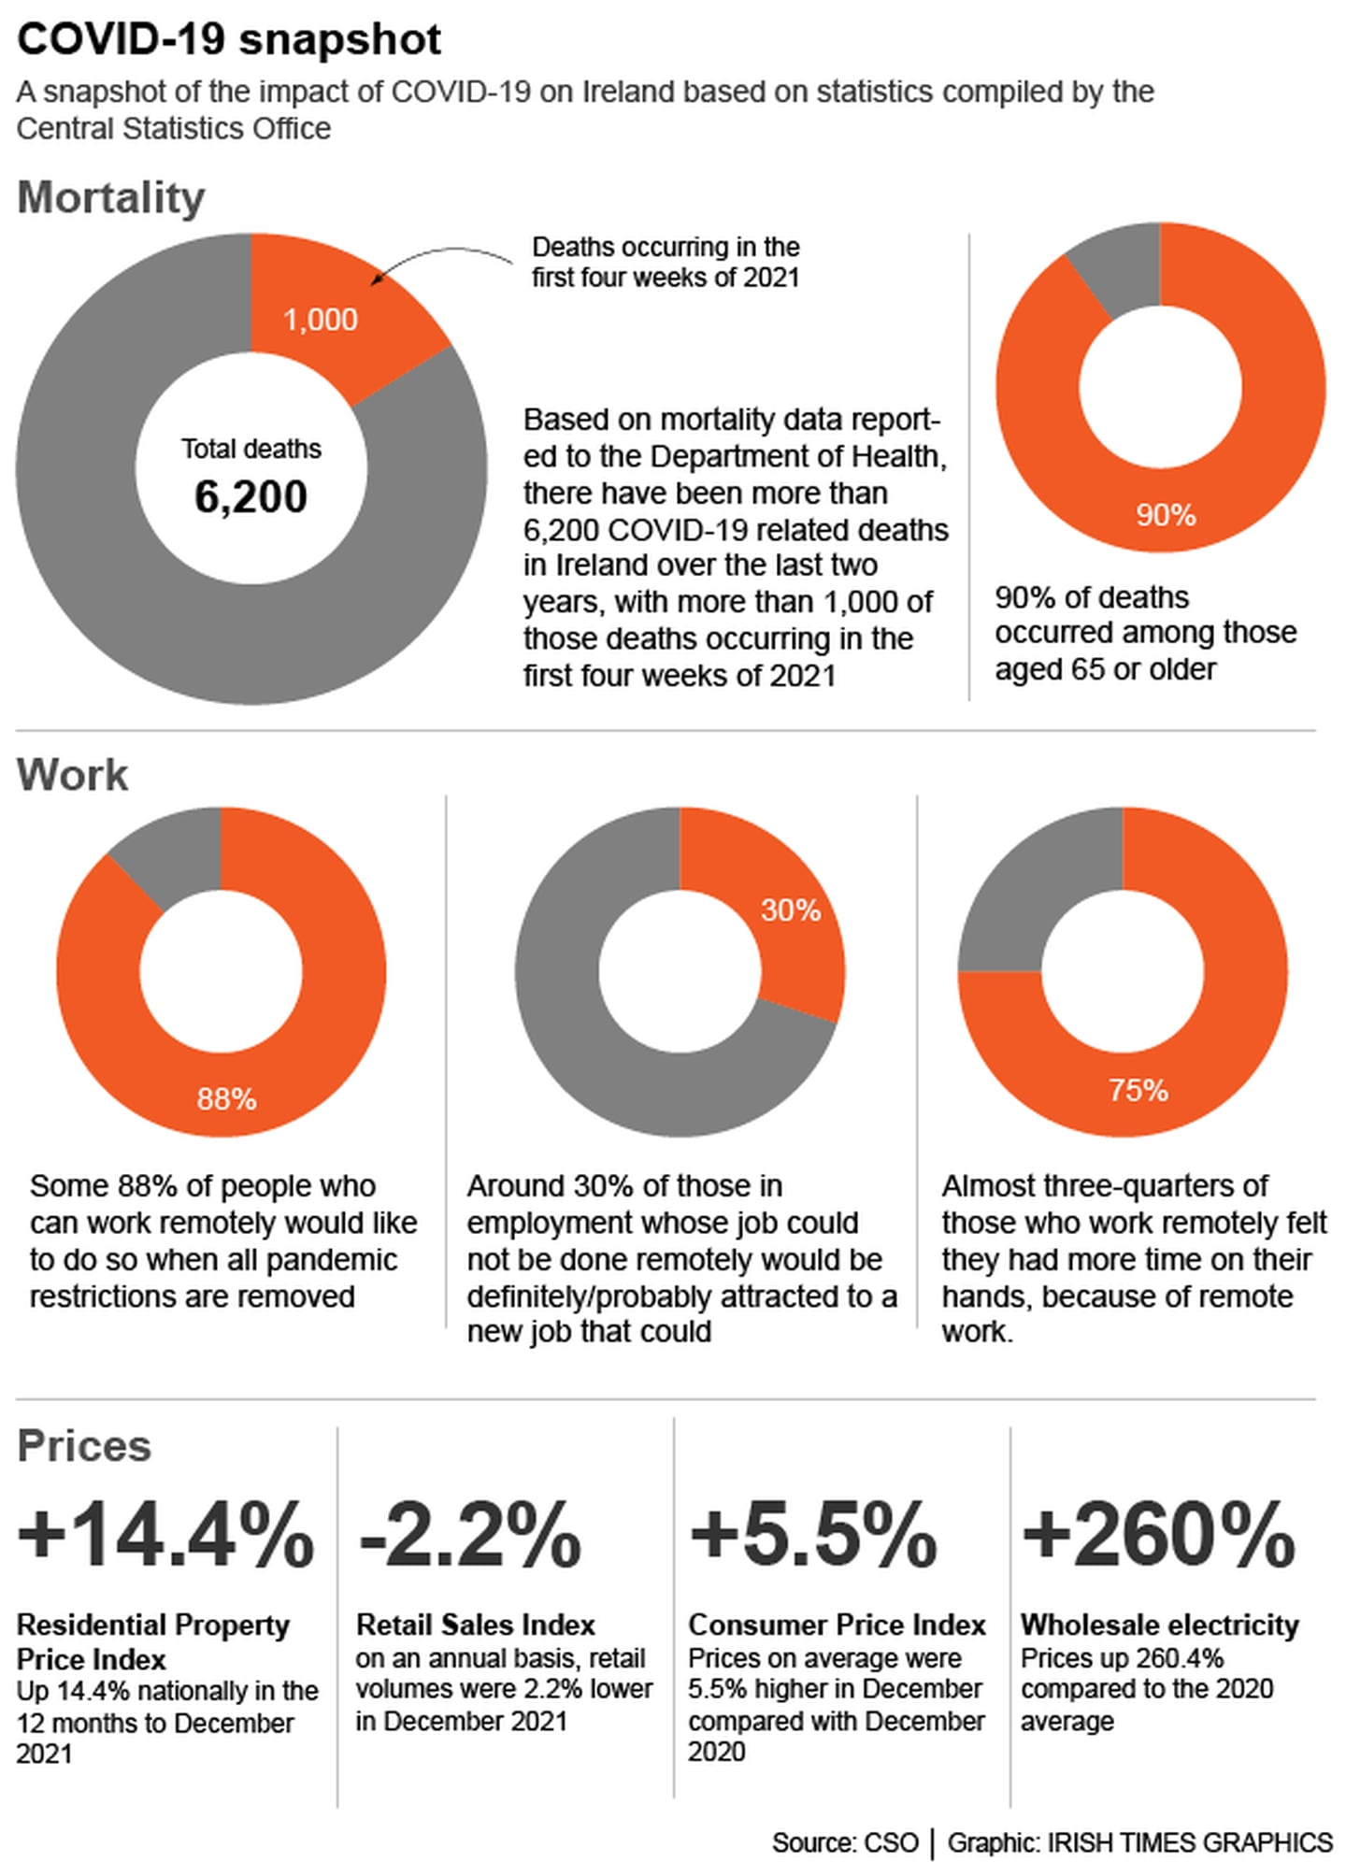

Figure 2.1 Impact of COVID-19 on Ireland based on statistic from the Central Statistical Office ([www.irishtimes.com](http://www.irishtimes.com))

In compare to period before pandemic with 20.8 billion eur, from January 2020 until end of September 2021 were saved by Households 54 billion.   
Unemployment rate faced 7.8 per cent at January 2022, within 7,4 per cent in December 2021 compare to 27.1 pre cent in January of 2021.

Labour force survey from final 3 month of 2021 shows that quantity of working people increased by 10.1 per cent or 229,200 from the December of same, state it is first time went to 2.5 million of people from 1998.

In relation of remote working 88% people who are able to continue do so would like to continue after removing restrictions. Also 30% would like to change job position from sector where remote working could not be done.

Increase of residential property on 14.4% from 2021 to 2022.

Crime statistic shows that from Autumn of 2021 to February 2022 that frauds cases increased on 72%. Which more related to unauthorised transactions and attempts to personalised banking information over online or over the phone. (Carswell S., 2022)

2.5. COVID -19 and digital payment

COVID – 19 pandemic shocked global banking with huge demand of digital payments over the other financial services.

According to Global Findex 2021 (worldbank.org (b)) database In 2011 – 51%, in 2017 – 68% of adults around the world are having account within bank or other financial institution, or mobile finance provider. In 2021 the number increase to 76%, and numbers of accounts since 2017 increases in double in 34 countries.

In countries of low and middle income such China and India with start of pandemic over 40% of adults uses digital payment for the first time. More than 30% related to payment bills from electronic account.

Nowadays over 60% adults worldwide do or receive digital payment, from 35% in 2014 and 57% in 2021. In developing economies, 71% are having account within bank, financial institution or with mobile financial provider from 42% in 2011 and 63% in 2017.

*“The digital revolution has catalysed increases in the access and use of financial services across the world, transforming ways in which people make and receive payments, borrow, and save,”* said **World Bank Group President David Malpass**. *“Creating an enabling policy environment, promoting the digitalization of payments, and further broadening access to formal accounts and financial services among women and the poor are some of the policy priorities to mitigate the reversals in development from the ongoing overlapping crises.”*

In Europe and Central Asia numbers of bank accounts of adults increased in 13% since 2017 and reach 78%. During COVID – 19 epidemic 10% of adults used digital banking for a first time. (worldbank.org (a))

2.6 History of smartphones

Mobile application is a software application that made to run on mobile devices – smartphones and tablets. Due to the evolutions of media, information technology, the internet, and advanced technologies, such applications have appeared. In early 70s IBM had an idea of portable computer-style phones, only in 1992 was able to release the prototype. First smartphone for general use was announced by IBM in 1993 and in 1994 phone Simon was launched on sale.

At a same time of late 90s, the wide spread had a stand-alone gadget, known as Personal Digital Assistants (PDA). With time phones and PDA are merge together for convenience in use. Companies such as Palm, Handspring, Nokia and Apple were producing various models of such devices.

The first device that was designed and represented to market is Erocsson R380, which was represented in 2000. Next year Palm lunched Kyocera 6035 – first smartphone with wireless data plan. Handspring in 2002 offered to public Treo 180 smartphone with GSM line Operating System with telephone, internet and text messaging services integrated.

Meanwhile in Japan company NTT DoCoMo in 1999 represented portable gadgets called i-mode with high-speed internet network as alternative approach from PDA/cell phones. It was using “compact HTML” or “cHTML”, which was allowed to render web pages. With 2 years from lunching, NTT DoCoMo had over 40 million subscribers.

Lunching first iPhone in 2007 was really intonationally product that changed the understanding of compute-based phone. One of main innovation was touchscreen-centric design, that become widely used since.

The touch sensor become element which people are able to check email, stream video, play audio and browse internet in same was as on personal computer. Unique iOS allowed to use intuitive gesture-based commands and place where third-party applications available for download.

Such a device represented that smartphones become available not just for people who interest in productivity, but for general public also, as a device of everyday usage and any kind usage: play games, watch movies, chat, share content, and much more that are still innovating up to now. (Nguyen T.C., 2021)

After lunching App store in 2008, Facebook had over a million downloads in less than year. In react on in company Google changed the Android OS strategy and at same year device HTCG1 had a large touchscreen, web browser that fully featured, and Android Market app store. (Nguyen T.C., 2023)

Samsung Galaxy S in 2010 removed switched functions touch buttons from screen and left only one single home button. And in next year of 2011 phones without any buttons were represented. Also, in 2011 smartphone with 4G LTE connection was launched for sale.

From 2010s many changes related to the smartphones were made. One of such improving camera quality. Nokia 808 won competition in such sector with 41 – megapixel camera sensor. Lumia 92 - first phone with optical image stabilisation (OIS). HUAWEI P20 Pro in 2018 was first triple-camera phone.

The 2010s shows Near Field Communication (NFC), eSIM support, and IP rating of water resistance and bunch of new sensors. Samsung had blood rate and oxygen saturation sensor in Galaxy S series. Nokia Lumia 920 in 2012 was first phone with QI wireless charging.

Compare to 2010s the 2020s technologies were bringing much less innovations in hardware – under camera sensors and magnetic accessories. Camera, that makes the phone anymore with low – resolution camera sensors as a standard. Form factor – foldable devices with fully functioning one peace touch screen.

However, innovations related software is making place. Generative AI and machine learning implementing peace by peace in smartphones. Latest devices are available to have direct connection with satellites which give options to new speed of data transfer and new way of phone usage. (Wankhede, C., 2023)

2.6 Mobile applications

Mobile application – software made to run on mobile devices, such as tablets, tablet computers, smartphones. As a result of technological innovations, mobile applications become to live. Nowadays, more than 80% of people are checking internet via mobile devices. And mobile applications have advantage over web pages with ease of use, quick on response and design related to portable devices.

2.6.1 Types of services by means of mobile application:

* Browser Access: The applications that uses native browser.
* Hybrid Apps – Web: need to install on phone, however the functionality works only with connection to internet.
* Hybrid Apps – Mixed: application need to be installed and functionality can require connection to internet.
* Native Apps – application which are installed in the device.

2.6.2 Goals of mobile application

Goal of mobile application have maximum number of users for maximum of time. To achieve this mobile application, require to have proper quality and purpose, to be liked by people all over globe. According to this application need to meet following requirements:

* Conformance to the purpose of users
* Ability to reach majority of users
* Security
* User – Friendly
* Continuedly updating and improving

*Advantages*:

* Increase of visibility. More presence on phone than browser.
* User engagement increasing.
* Less cost of marketing content promotions than 3rd party massagers and commercial promos.

*Disadvantages*:

* Teenagers are in risk of time spending with social media and mobile or web games instead of useful information.
* Convenience in use can create destructions in public places including transport.
* Frequency in use can have a bad reflection on physical and mental health. (Phongtraychack 2018)

2.6.3 History of mobile applications

As a first mobile applications can take the games of Snake, Pong, Tetris and Tic-Tac-Toe that were adapted to mobile phones.

Within time more features and games were created. However, manufacturers were not putting much effort to provide users with any application that they want.

First web sites were having issues to represent themselves in a way of not well – optimised technology, which was not able to give proper view on small screens of first mobile phones.

Wireless Application Protocol (WAP) was represented to help with such limitations. It was stripped down version of HTTP – World Wide Web basic protocols. It was great solution to run within memory and connections speed limitations. This gives an option to manufactures to build in the WAP browser in they devices and also provide an WAP portal with additional services on it. However, limitations were related to lack of availability.

Another issue was related to purchasing inside WAP applications, the billing mechanism was not built-in. Order was sent to application and payment was need to processed over the network provider via Short Message Service (SMS) or Enhanced Message Service (EMS), Multimedia Messaging Service (MMS), and WAP Push. Browser itself was slow and contained multiple issues. It was not very user friendly and User Experience was on medium level. WAP technology didn`t gain popularity except Japan and few other places. Small screens – too small for surfing internet, reading was followed interruptions   
to download next segment, every download was taking the valued traffic that was expensive. That`s why some of critics calls WAP as “Wait and Pay.”

With improving PDA gadgets more mobile platform appears it such as:

* Palm OS (Garnet OS)
* RIM Blackberry OS
* Java Micro Edition (Java ME)
* Binary Environment for Wireless (BREW) from Qualcomm.
* Symbian OS
* iOS
* Android

Each platform had as benefits and issues. All of them had a big concurrence for the customer. Some more suitable for games other for hobbies. No one was suitable properly for all of the mobile applications. Fragmentation of market continues related to region, preferences and so on. Operators were forced to sell phones of all different platforms. With separation of market the community as fragmented as well. Software developers are faced to work with different tools, programming environment and even languages. Making cross platform applications is become important for mobile market, because adapting already built application to another platform requires a lot of cost and effort.

Developing mobile application nowadays require to made a choice – Apple or Googe; Proprietary or open – source. All of this is related to goals of desired mobile application. (Clark, J. F., 2012)

2.7 Android Operation System.

Android appeared on market shelves on 2008. Since than it was open – source operating system, which was the main key in Google`s decision. Third – party phone makers take this OS very enthusiastically. After only 1 year Android 1.0, smartphones with new OS were everywhere.

Current version of OS in Android 14. And it`s still globally most popular mobile OS in the world. Only platform that somehow can compete with Android is Apple iOS.

(Callaham, 2023)

2.7.1 History of Android OS

In October 2003 Android Inc was founded in Palo Alto California by Rich Miner, Nick Sears, Chris White and Andy Rubin. Rubin said that they are going to developed “smarter mobile devices that are more aware of its owner`s location and preferences.” Also, in Tokio in 2013 in speech mentioned that originally purpose of Android OS was improve digital cameras. However, in few months after start of development switched to mobile phones.

In 2005 after Google bought the Android company – it brought huge changes. Developers decided to use Linux as a base for the Android OS. It gives option to use OS by 3rd party mobile manufacturers for free. It was designed to get profit on services such as applications. (Callaham, 2023)

Having free of charge of use Android OS made it high interested in use by manufactures. And over time more and more companies are start to use it, which replaced another mobile OS. (Amadeo R., 2016)

From 2012 as 28% up to 2023 with 70,46% of mobile phones in the world Android OS was and is in the majority on the market. That is represented by Figure 2.2

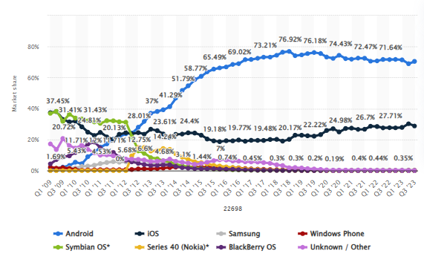

Figure 2.2 – Global market of Operation systems from 2009 to 2023 (statista.com 2023)

In Ireland the percentage of Android based mobile devices is slightly less that in global world, nevertheless it still on the top with 53.76% on November 2023 it`s related that 45.88% of mobile users are using iPhone. Shares are graphically represented on Figure 2.3

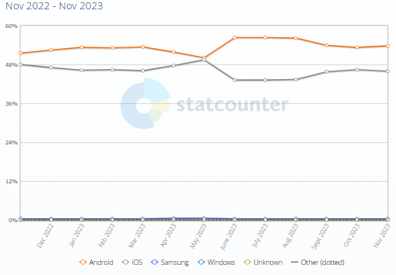

Figure 2.3 – Mobile Operating Systems Market Share in Ireland from Nov 2022 to Nov 2023

2.6.5 Version of Android System

Android 1.0 – 1.1

This version was launched in 2008 and was not having the sweet name like others. At that time, it was having basic services from Google – Gmail, Maps, Calendar and YouTube, all of them were integrated in OS. Home page and browsing are represented on Figure 2.4 (Rafael, J., 2023)

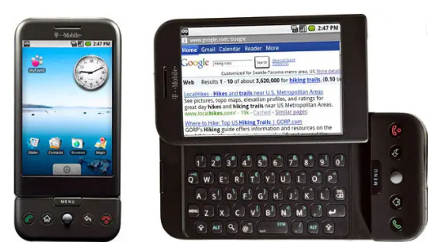

Figure 2.4 – Android 1.0 home screen and it`s web browsing (Raphael, J., 2023)

Android 1.5: Cupcake

With this version from early 2009`s the tradition of naming Android related to some of sweets was born. This introduced the screen virtual keyboard.

Was represented a framework for third-party app widgets, together with option of video recording.

Android 1.6: Donut

Gives option to operate on screens with different sizes. Added support of CDMA network.

Android 2.0 and 2.1: Éclair

Was added feature of voice navigation and real-time traffic info, live wallpapers as well with speech-to-text function. Also brought pinch-to-zoom capability.

Android 2.2: Froyo

Revolved the performance. Introduced the dock home button which is become standard over years together with Voice Actions – performing basic functions without typing on icons but by voice. Flash and Android`s web browsers became available – which was a huge step at a time.

Android 2.3: Gingerbread

In 2010 released it represents the visual identity of OS. Black and Green was main colours of the UI same as mascot of Android – Bugdroid.

Android 3.0 – 3.2: Honeycomb

Versions of 3.1 and 3.2 in 2011 was developed specially for tablets. The UI was changed incredibly. The UI of such versions represented on Figure 2.5. And looks more like modern PC OS than for Mobile device.

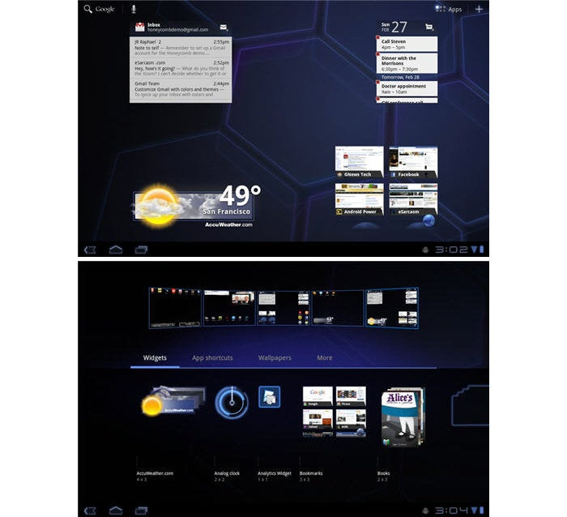

Figure 2.5 – Android 3.1 and 3.2 Honeycomb Home page and dock page (Raphael, J., 2023)

Android 4.0: Ice Cream Sandwich

It was experiments of modern design with having single version of UI for Android and Tablet devices. Start using sweeping as more appropriate method of navigation in OS.

Android 4.1 – 4.3: Jelly Bean

Makes the usage of device more smoothly by using ICS`s. UI become more recognisable that what we have in modern android devices. Google Now was implemented – in future evolved as news feed. Expended notification and search system and more features for displaying users search with answering questions directly.

Having multiusers option on tablets and quick setting drop down menu first comes from the Jelly Bean UI of which is represented on Figure 2.6

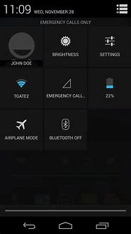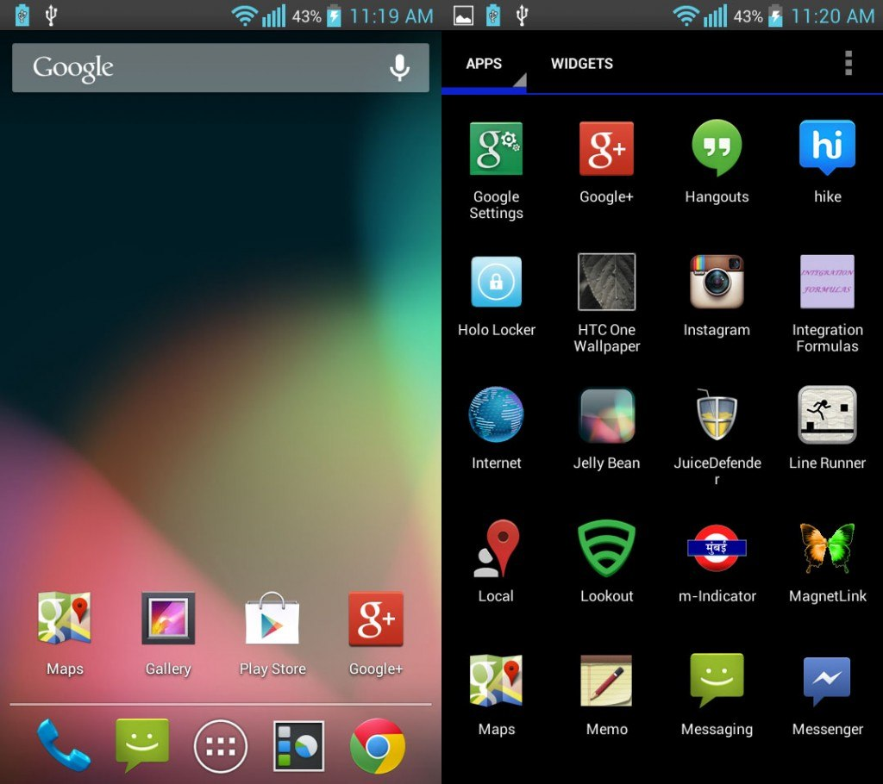

Figure 2.6 – Android: Jelly Bean UI – quick setting menu, home screen and application screen. (Raphael, J., 2023)

Android 5.0 – 5.1: Lollipop

“Ok, Google” voice control was introduced, multiple users support on a phone and priority mode for management of notifications. However released version was not polished and many issues was fixed with 5.1

Android 6.0: Marshmallow

Minor android release, however it created a trend of having one major update from Google on each year.

Many features was introduced lasting impact, though, more app premotions, support fingerprint readers and USB-C port.

Android 7.0 – 7.1: Nougat

Split screen mode become available, notification organising and Data Saver feature. UI gave option to snapping between apps and other shortcuts. Google assistant become available. Was represented Google first fully self-made phone – Pixel.

Android 8.0 and 8.1: Oreo

Many nice elements were added such a native picture-in-picture mode, a notification snoozing potion, control of alerts options for notifications.

2017 also give a release of Chrome OS with option to use Android apps on Chromebooks.

Android 9: Pie

2018 brought hybrid gesture/button navigation system, keys become multifunctional, especially Home button and small black button alongside. Noteworthy productivity features: universal suggested – reply system, digital wellbeing control, power and screen bright management. Smaller but important advancements such as smarter hotspot handle, welcome to Android Battery Saver mode, and more privacy and security improvements.

Android 10  
First android version without reference to some kind of desert was represented in 2019. Gestures was reconsidered, swipe-driven system navigation was more in use. Many quality features were implemented within new permission system related location, new dark theme, Focus-Mode to remove distractions, live captioning system for playing media.

Android 11

September 2020, brought many changes, as seen together within unseen. Privacy was main focus of such update. Permissions of location, camera and microphone become available for single-use only.

UI reconsider approach of conversation – relation notifications together with new streamlined media player, new Notification History window, native screen recording, and menu to manage connected devices.

Android 12:

Represented in October 2021 having the biggest reimagining of UI since 2014 showing new design standard – Material You where you – is who able customise the look of the device. With changing of wallpapers, the theme of the phone changes automatically as well. Widgets comes back to focus of the system. Increasing in security, performance and privacy. Way of usage data on the phone become more customisable by user. New section that isolated and allowing AI to operate on device, without any potential leak of data. Home screen and Quick Settings Menu represented on Figure 2.7

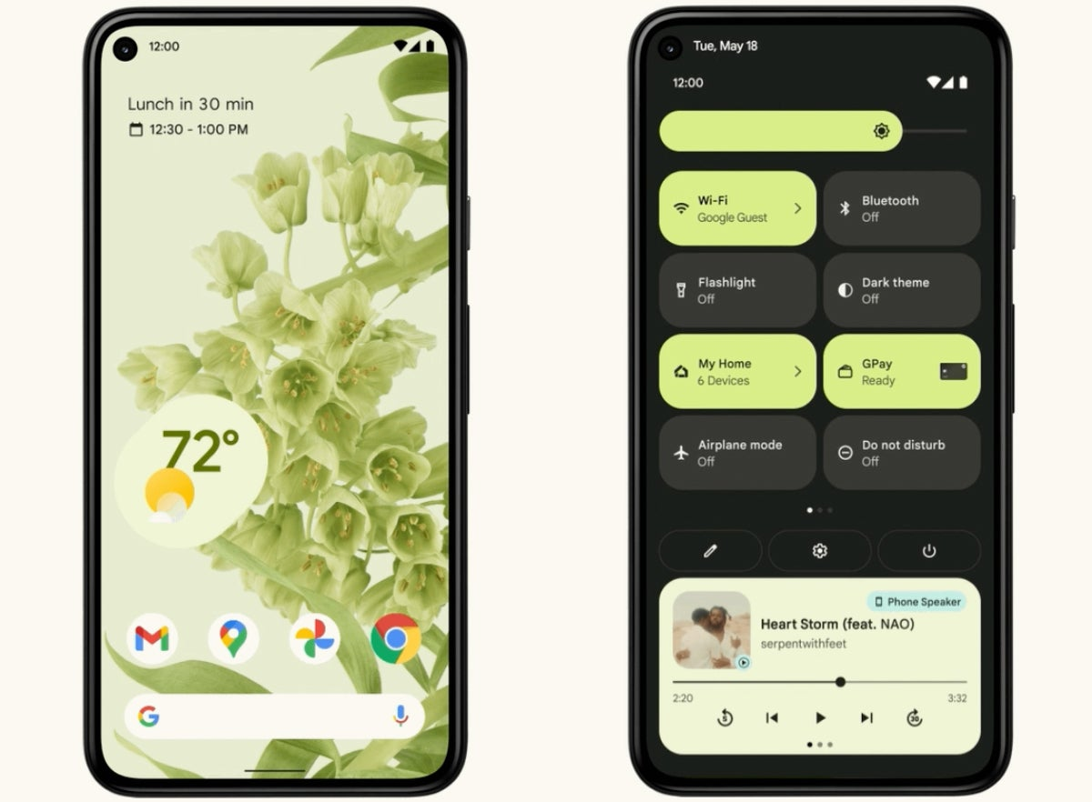

Figure 2.7 – Home screen and Quich Setting Menu of Android 12 (Raphael, J., 2023)

Android 13:

Stated as one of the most controversial updates in August 2022, being ambition and subtle at the same time. Tablets and Foldable phones received a whole new interface. Frash frameworks and guides for app developers with the option to have an easy spleen screen on Chrome devices. Pixel Tablets function as Smart Display within the detaching screen and are used as tablet. A new series of shared-surface widgets together with screensavers become supported. Taking to consider regular phones – the difference from Android 12 is much less. Expanded clipboard allowed to correct text that is copied, native QR scanner together with Android Quick Setting area and improvement of privacy, security and performance

Android 14:

Was represented in October 23 together with new Google Pixel 8 and Pixel 8 Pro. On first look changes related to UI of Android 13 in a way that it removes from smaller updates to launching big changes in system. New system of dragging and dropping text between apps were introduced together with native customisation of lock screen. Privacy and security improvements, specially related to health and fitness data control. Added feature that checking the reason why specific permission is asked for. Hoge accessibility additions – increasing fonts in any apps, enhanced magnifier, flashing light on the main camera any time when arrives notification. (Raphael, J., 2023)

2.7 Case Studies on Similar Mobile Applications

Gathering information about applications related to “handmade products” or “artisans marketplace” mostly gives options of Eatsy, Faulksy and Amazon Handmade, which are already represented in The Project Proposal.

2.7.1 Megastores.com

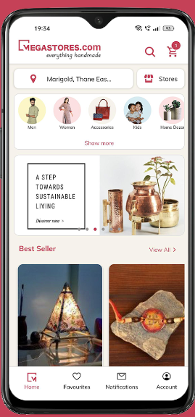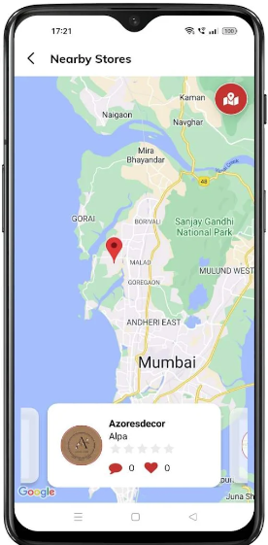

Figure 2.8 (a,b): Megastores.com pages of mobile application. (Megastores (a))

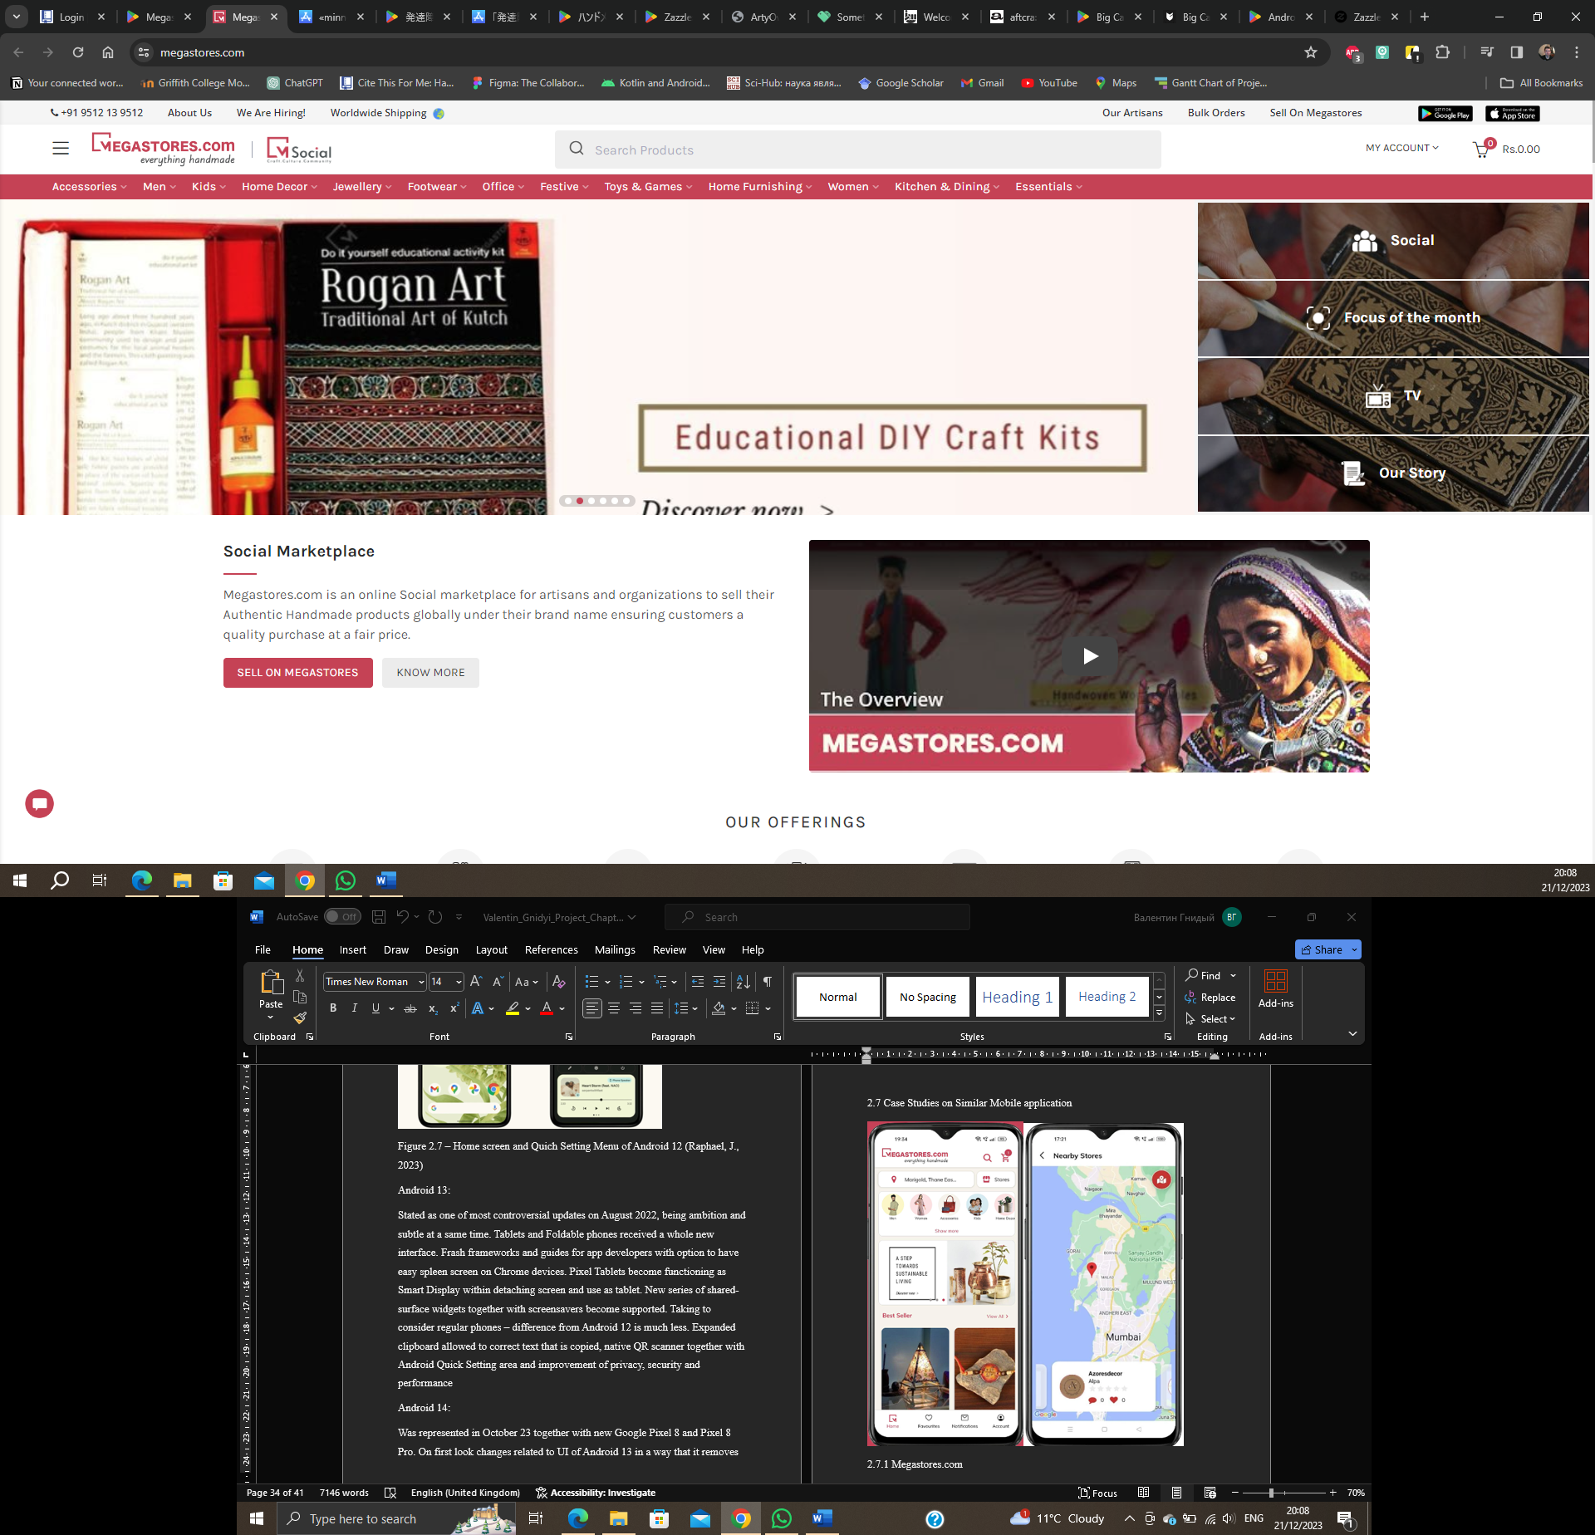  
Figure 2.8 (c): Megastores.com home page of web application. (Megastores (b))

* Online marketplace Megastores is focused on globalising artisans located in India and neighbouring countries.
* Pleasant design and proper navigation.
* Purchase products by using online wallets is optional.
* Social media sharing of products is integrated.

Not having

* Offline registration. Registration for users is processed online – the handmade products can be impersonated.
* Artisan's location can`t be checked by map.
* Not able to connect to the seller anyway but during the order and feedback.
* Not optional to request custom-made products.
* No chat no forum is implemented.

Even considering that the platform was built only as a selling marketplace – the design looks very pleasant and can be inspiring for creating the current development project.

2.7.2 Zazzle.com   
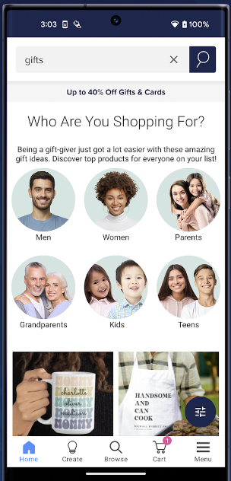 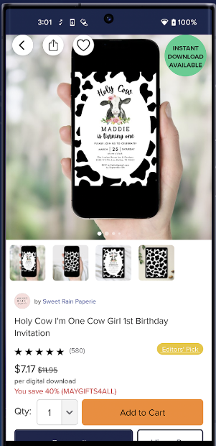 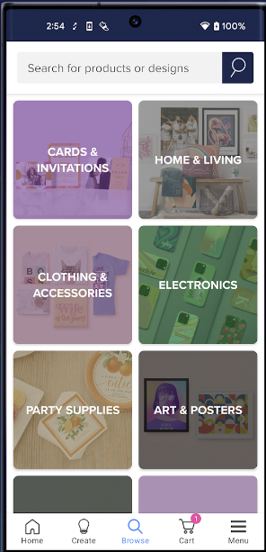

Figure 2.9 (a-c): Zazzle mobile application screens (Zazzle (a))

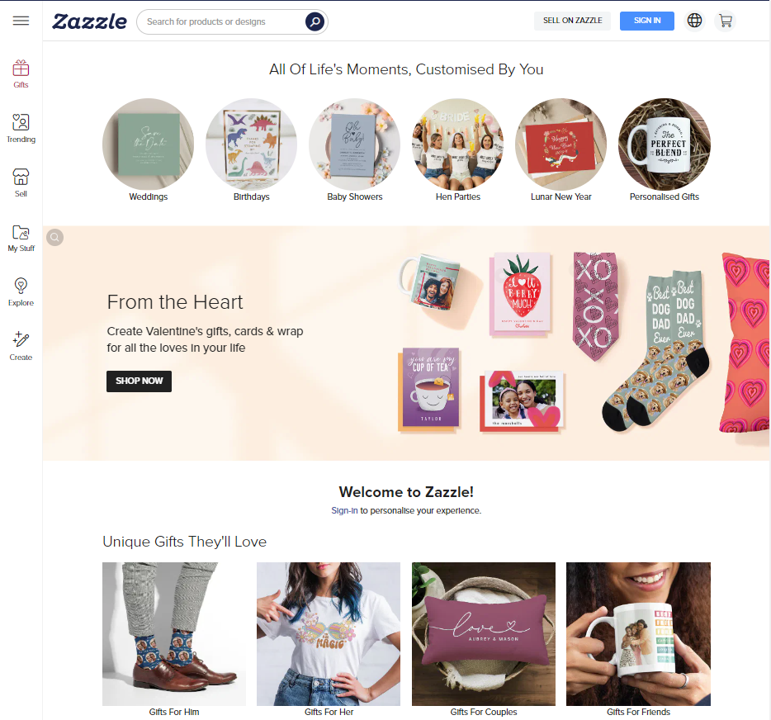

Figure 2.9 d: Zazzle web application main page. (Zazzle (b)  
Marketplace of custom-made cards and designed gifts. Based in the UK however, artisans worldwide are using this platform to sell their handmade products.

* Web applications inherit the main principles of the mobile – less cluttered without overfilling of information.
* Navigation is easy and intuitively understandable.
* Easy to contact sellers and request custom-made orders.
* Usage of online wallets.

Not having:

* The range of products is very limited as a platform for gifts.
* Artisans are not represented on the map, only in individual manual checks showing the city in the information window from the seller, which can be not comfortable for some users.
* Very low representation of Irish sellers.
* No availability of forums for artisans.

2.7.3 ArtyOwl

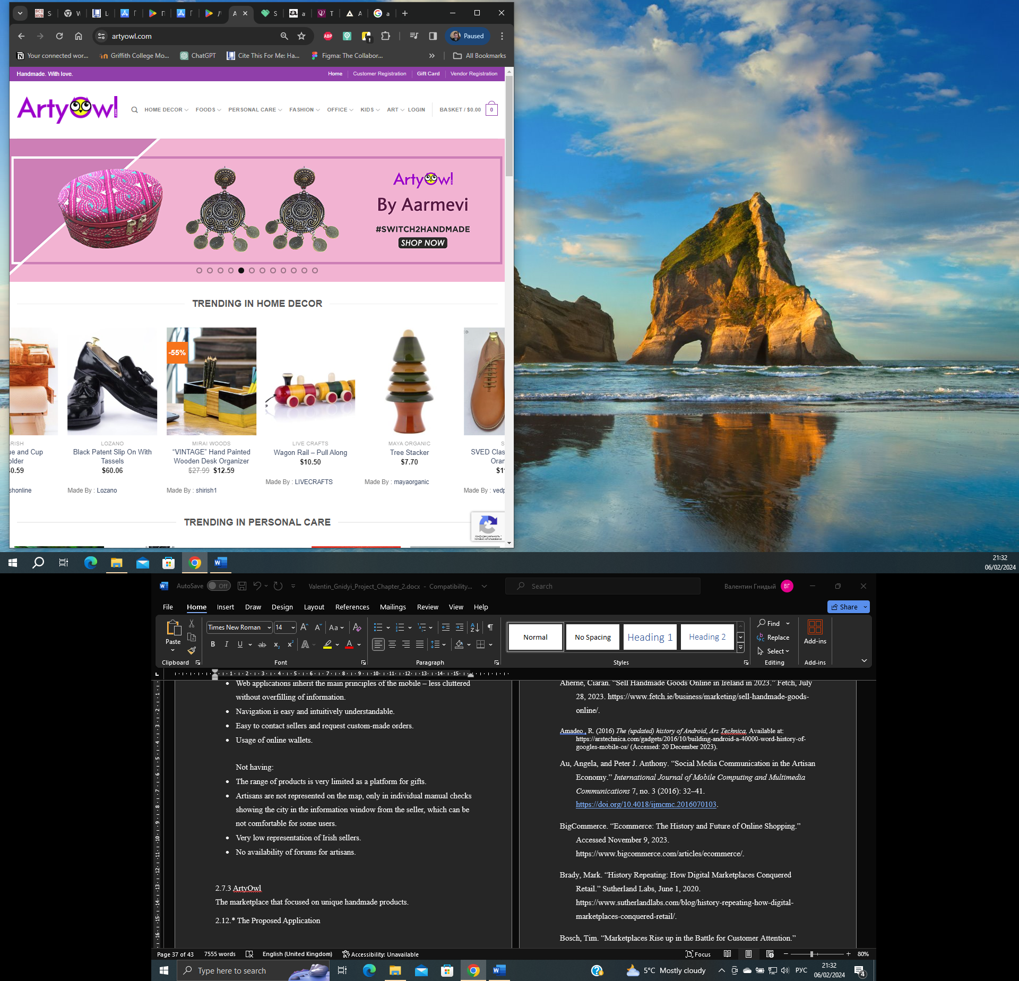

Figure 2.10: ArtyOwl main web application page (AtryOwl.com)

The marketplace focused on unique handmade products. Launched in 2016 in the USA, but still does not have a proper mobile application, and continues to have only a web version.

* Attractive design
* Proper and intuitive understanding of navigation
* Variety of available products.
* Integrated option to share liked products over social media.
* Online registration with the request of legally recognised documents to partly prevent personalisation. (KYC, Tax Number)

Not having:

* No direct chat to the seller – only after request of product.
* Not having representation of artisan location.

Given platform gives an interesting approach related to preventing personalisation can be considered for implementation in future iterations.

2.12. The Proposed Application

The *Irish Artisans* aims to create a platform that gathers local artisans in the vicinity of Ireland Limerick and the general public. This will increase the interest of the local community in handmade products and the people who make them. Giving a space for artisans and a public where both can benefit from each other gives more possibilities to encourage people to be more creative together with passionate customers.

The mobile application will be represented as a *marketplace* where local artisans can list and sell their handmade products directly. Customers will be able to have a wide range of available products, from creators in their community, such as artworks, crafts, jewellery, clothing, and more. Proposed products can help users discover unique products and personalised items that can fit their wishes and preferences.

Users will have the ability to follow their favourite artisans, communicate directly, give feedback on the platform together and share desired products over social media. This not only will enhance the user experience but can help authors and artisans connect and collaborate on projects.

Overall, the proposed mobile application will increase the community interest in local artisans and people of arts by representing their products to a wider population and will help with better communication and feedback that enhance creativity and craftsmanship.

2.13 Chapter Summary

In 2023 selling handmade products related to many challenges. Online representation, become a huge part of it. Many artisans and authors are using huge platforms such as Etsy and Amazon Handmade. Such a platform is not focused on the local community and has many problems such as worldwide concurrence, impersonation and others. The proposed application will empower the makers to be more recognised in the local community and reach for potential customers, together with easier communication and feedback can help to master better craft and increase quality of products.

The Next Chapter will discuss the Project Application Analysis phase, the Development Methodology that was chosen for the current project, and the Alternative Design Solution that is going to be implemented in the developed mobile application.

References:

Aherne, Ciaran. “Sell Handmade Goods Online in Ireland in 2023.” Fetch, July 28, 2023. (Online)  
Available at: https://www.fetch.ie/business/marketing/sell-handmade-goods-online/. (Accessible at: 2, December, 2023)

Amadeo , R. (2016) *The (updated) history of Android*, *Ars Technica*. (Online) Available at: https://arstechnica.com/gadgets/2016/10/building-android-a-40000-word-history-of-googles-mobile-os/ (Accessed: 20 December 2023).

Au, Angela, and Peter J. Anthony. “Social Media Communication in the Artisan Economy.” *International Journal of Mobile Computing and Multimedia Communications* 7, no. 3 (2016): 32–41. <https://doi.org/10.4018/ijmcmc.2016070103>.

*A unique marketplace for Handmade Wonders* (2023) *ArtyOwl*. (Online) Available at: https://artyowl.com/ (Accessed: 20 January 2024).

BigCommerce. “Ecommerce: The History and Future of Online Shopping.” (Online) Available at: https://www.bigcommerce.com/articles/ecommerce/. (Accessed: 9, November, 2023.)

Brady, Mark. “History Repeating: How Digital Marketplaces Conquered Retail.” Sutherland Labs, June 1, 2020. (Online)  
Available at:  
https://www.sutherlandlabs.com/blog/history-repeating-how-digital-marketplaces-conquered-retail/. (Accessed: 16, November, 2023)

Bosch, Tim. “Marketplaces Rise up in the Battle for Customer Attention.” Wunderman Thompson. (Online) Accessible at: <https://www.wundermanthompson.com/insight/marketplace-ecommerce-opportunity#:~:text=It%20didn’t%20take%20long,back%20in%20time%20even%20further>. (Accessed November 9, 2023.)

Callaham, J. (2023) *The history of Android: The evolution of the biggest Mobile OS in the world*, *Android Authority*. (Online) Available at: https://www.androidauthority.com/history-android-os-name-789433/ (Accessed: 20 December 2023).

Carswell, S. (2022) *Revealed: The full impact of covid-19 on society and the economy*, *The Irish Times*. (Online) Available at: https://www.irishtimes.com/news/ireland/irish-news/revealed-the-full-impact-of-covid-19-on-society-and-the-economy-1.4810052 (Accessed: 17 December 2023).

CompuServe, About CompuServe. (Online) Available at: https://www.compuserve.com/home/about.jsp?guccounter=1&guce_referrer=aHR0cHM6Ly93d3cuYmlnY29tbWVyY2UuY29tL2FydGljbGVzL2Vjb21tZXJjZS8&guce_referrer_sig=AQAAACJgl4urEK7JKPXxjKJIA8oUNxrByJwhpRVWYdYGJOwjTxmPLgRVgd0cjpcmF__sjpL5VWsVnZGbTj3mo2skEzvRU7QiK7_xoIisNDo6SCNc2qsL83K7YcIEGY59yxvf-vn7iXliJ82W3kYb40_kHQ8CTWAqZgH5jc30SIdCAHU4. (Accessed: 9 November 2023.)

Cloudfare.com *What is data privacy? | privacy definition | cloudflare*. (Online) Available at: https://www.cloudflare.com/learning/privacy/what-is-data-privacy/ (Accessed: 15 November 2023).

Chevalier (a), Stephanie. “Leading E-Commerce Companies by Revenue CAGR 2023.” Statista, October 16, 2023. (Online) Available at: https://www.statista.com/statistics/1039587/leading-online-marketplaces-by-cagr/. (Accessed: 9 November 2023)

Chevalier (b), Stephanie. “Topic: Online Marketplaces.” Statista. (Online) Available at: https://www.statista.com/topics/4827/online-marketplaces/#topicOverview. (Accessed 9 November 2023.)

Clark, J.F. (2012) *History of mobile applications - University of Kentucky*. (Online) Available at: https://www.uky.edu/~jclark/mas490apps/History%20of%20Mobile%20Apps.pdf (Accessed: 18 December 2023).

Google.com *Firebase Support*, *Google*. (Online) Available at: https://firebase.google.com/support#data_protection (Accessed: 15 November 2023).

Hey, Erin. “Craft Trends to Make & Sell (in 2023).” Made Urban, February 13, 2023. (Online) Available at: https://www.madeurban.com/blog/craft-trends-to-make-sell-in-2022/. (Accessed at 23 November 2023)

*Internet purchases - CSO - central statistics office* (2020) *CSO*. (Online) Available at: https://www.cso.ie/en/releasesandpublications/ep/p-isshh/informationsocietystatistics-households2020/internetpurchases/ (Accessed: 12 December 2023).

James, S.P. and Corbitt, B.J. (2003) *(PDF) mobile banking: Concept and potential - researchgate*, *Mobile banking: Concept and potential*. (Online) Available at: https://www.researchgate.net/publication/220474699_Mobile_banking_Concept_and_potential (Accessed: 15 December 2023).

*Mobile OS market share worldwide 2009-2023* (2023) *Statista*. (Online) Available at: https://www.statista.com/statistics/272698/global-market-share-held-by-mobile-operating-systems-since-2009/ (Accessed: 20 December 2023).

*Megastores(a) everything handmade - apps on Google Play*, *Google*. (Online) Available at: https://play.google.com/store/apps/details?id=com.atulsia.megastores&hl=en&gl=US&pli=1 (Accessed: 14 January 2024).

*Megastores(b) Remarkable online marketplace for authentic Indian handicrafts and handlooms,*.(Online) Available at: https://www.megastores.com/ (Accessed: 14 January 2024).

Nguyen, T.C. (2021) *You might be surprised to learn who invented smartphones*, *ThoughtCo*. (Online) Available at: https://www.thoughtco.com/history-of-smartphones-4096585 (Accessed: 17 December 2023).

Nguyen, T.C. (2023) *The history of cell phones: A decade-by-decade timeline*, *Android Authority*. (Online) Available at: https://www.androidauthority.com/history-of-cell-phones-timeline-3264425/ (Accessed: 18 December 2023).

The Design Trust . “The 39 Best Places to Sell Handmade Crafts Online.” The Design Trust, May 12, 2023.(Online) Available at: https://www.thedesigntrust.co.uk/best-places-to-sell-your-crafts-online/. (Accessed 23 November 2023)

Phongtraychack, A. and Dolgaya, D. (2018) ‘Evolution of mobile applications’, *MATEC Web of Conferences*, 155, p. 01027. doi:10.1051/matecconf/201815501027.

Ponce de Leon, Tomas. “The Rise of the Marketplace: Winning in an Evolving Retail Landscape.” Forbes, August 25, 2023. (Online) Available at: https://www.forbes.com/sites/walmart-marketplace/2023/08/24/the-rise-of-the-marketplace-winning-in-an-evolving-retail-landscape/?sh=16e0f5478a4d. (Accessed at: 25 November 2023)

*Secure Payment Systems explained,* *Stripe*. (Online) Available at: https://stripe.com/ie/resources/more/secure-payment-systems-explained (Accessed: 13 December 2023).

Selgin, G.A. *Historical development*, *Encyclopædia Britannica*. (Online) Available at: https://www.britannica.com/money/topic/bank/Historical-development (Accessed: 14 December 2023).

Salamzadeh, Aidin. “How Artisans and Arts Entrepreneurs Use Social Media Platforms?” Journal of Organizational Culture, Communications and Conflict, March 16, 2021. (Online) https://www.abacademies.org/articles/how-artisans-and-arts-entrepreneurs-use-social-media-platforms-10276.html. (Accessed at: 25 November, 2023)

SlashGear (2022) *What happened to the essential phone?*, *SlashGear*. (Online) Available at: https://www.slashgear.com/772676/what-happened-to-the-essential-phone/ (Accessed: 20 December 2023).

Stark, Erza. “A History of Shopping, Marketplaces, and Experiences: Stark Enterprises.” Stark Enterprises |, February 12, 2021. (Online) https://starkenterprises.com/a-history-of-shopping-marketplaces-and-experiences/. (Accessed at: 27 November 2023)

Tamarack Foundation for the Arts. Intellectual property guide for artisans - tamarackfoundation.org, October 23, 2016. (Online) https://tamarackfoundation.org/wp-content/uploads/2016/02/Tamarack-Copyright-Memo-10.23.2016.pdf. (Accessed: 16 November 2023)

Kalaitzakis , A. (2020) *(PDF) The Evolution of Banking: From retail to Mobile Banks and Fintech*, *The Evolution of Banking: From Retail to Mobile Banks and Fintech June 2020*. (Online) Available at: https://www.researchgate.net/publication/343796933_The_Evolution_of_Banking_From_Retail_to_Mobile_Banks_and_Fintech (Accessed: 14 December 2023).

Kovalchyk, Olena, and Iryna Kovalchyk. “Analysis of the Main Global Trends for E-Commerce.” *Socio-Economic Problems and the State* 25, no. 2 (2021): 541–49. https://doi.org/10.33108/sepd2022.02.541.

Kunst, Alexander. “Most Common Online Purchases by Device in the U.S. 2022.” Statista, March 16, 2023. (Online) Available at: https://www.statista.com/forecasts/997098/most-common-online-purchases-by-device-in-the-us. (Accessed at: 1 December 2023)

Mitchell, Morgan. “The History and Evolution of Marketplaces.” Modo25, July 18, 2022. (Online) Available at: https://modo25.com/news-insights/insights/the-history-and-evolution-of-marketplaces/. (Accessed at: 20 November 2023)

Phongtraychack, Anachack, and Darya Dolgaya. “Evolution of Mobile Applications.” *MATEC Web of Conferences*, 01027, 155 (February 28, 2018). https://doi.org/10.1051/matecconf/201815501027.

Wankhede, C. (2023) *The history of cell phones: A decade-by-decade timeline*, *Android Authority*. (Online) Available at: https://www.androidauthority.com/history-of-cell-phones-timeline-3264425/ (Accessed: 18 December 2023).

World Bank Group (a) (2022) *Covid-19 drives global surge in use of digital payments*, *World Bank*. (Online) Available at: https://www.worldbank.org/en/news/press-release/2022/06/29/covid-19-drives-global-surge-in-use-of-digital-payments (Accessed: 19 December 2023).

World Bank Group (b) *The global findex database 2021*, *World Bank*. (Online) Available at: https://www.worldbank.org/en/publication/globalfindex (Accessed: 19 December 2023).

*Zazzle (a): Custom gifts & cards - apps on Google Play* *Google*. (Online) Available at: https://play.google.com/store/apps/details?id=com.zazzle (Accessed: 12 January 2024).

*Zazzle (b) UK - shop personalised gifts, custom products, instant downloads & unique gift ideas for everyone* *Zazzle UK - Shop personalised gifts, custom products, Instant Downloads & unique gift ideas for everyone*. (Online) Available at: https://www.zazzle.co.uk/ (Accessed: 14 January 2024).